**PS Lab 8**

1)

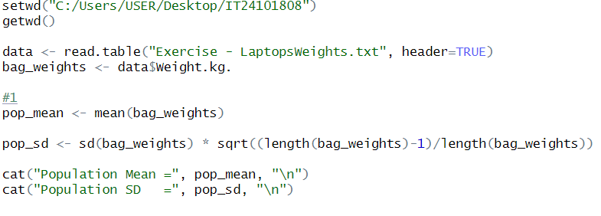

2)

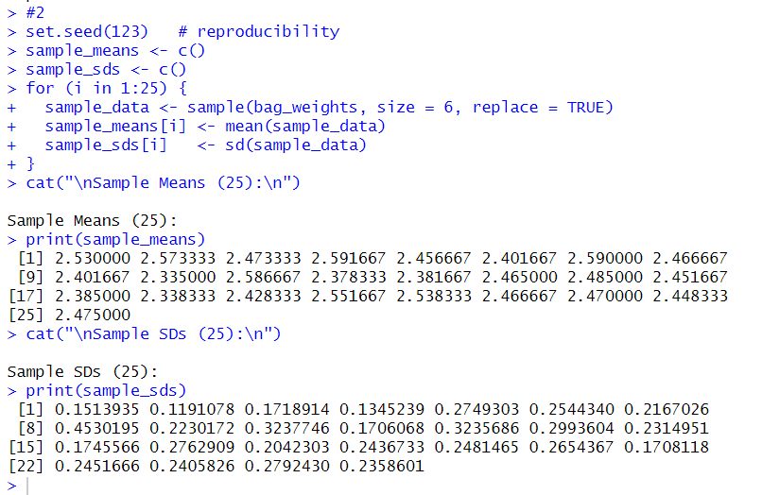

3)

